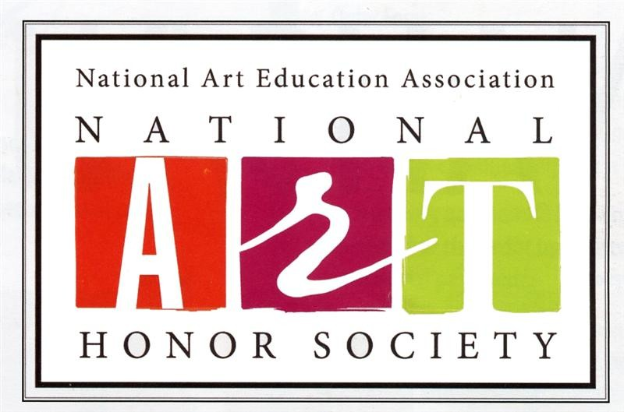
GWHS NAHS Service Hours Tracking Form
You are required to obtain 10 art-based community service hours to maintain a standing membership within National Art Honor Society. Please use this tracking form to document your volunteer work and record hours. Bring the form with you to obtain the Coordinator’s signature after each project is finished. We cannot accept lost or misplaced forms; please hold onto your copy tightly. After you have completed the 10 required hours of service, turn your form into Ms. Mamatas in the photography room, 230. Here’s to making the world a more beautiful and artful place!
Student Name:___________________________________________________________________
Phone:_____________________________ Email:_______________________________________
Date | Service Project | IN | OUT | Hours | Coordinator Name | Coordinator Email | Coordinator Signature
TOTAL HOURS:

Verifying Name of NAHS HHS Teacher Sponsor: ___________________________________________________________
Verifying Signature of NAHS HHS Teacher Sponsor: ___________________________________________________________

